SDG&E’s Renewable Energy Self-Generation Bill Credit Transfer (RES-BCT) tariff was approved by the CPUC in accordance with Public Utilities Code 2830, which was the statute created by Assembly Bill 2466. The RES-BCT tariff allows “Local Governments” to generate electricity using an eligible Renewable electrical generation facility with a capacity up to 5 megawatts at one generating account and transfer excess bill credits to another SDG&E electricity account billing under the name of the same Local Government. Local Governments include cities, counties, special districts, school districts, political subdivision, other local public agency, or a joint powers authority. Local Governments also include individual campuses of the University of California or the California State University.
SDG&E is authorized to provide service under Schedule RES-BCT on a first-come, first-served basis until the combined rated generating capacity of participating renewable electrical generation facilities reaches a total of 20.25 MW within its service territory.
Prior to participating in SDG&E’s RES-BCT program, eligible customers must first apply for authorization to interconnect their generator(s) to SDG&E’s electric system. Please follow the Rule 21 interconnection process information found on this web page.
During the month of December 2024, no new projects received permission to operate an electrical generating facility under the RES-BCT program.
The table provided below contains the current RES-BCT program status and it will be updated on a monthly basis. The table was last updated on January 1, 2025.
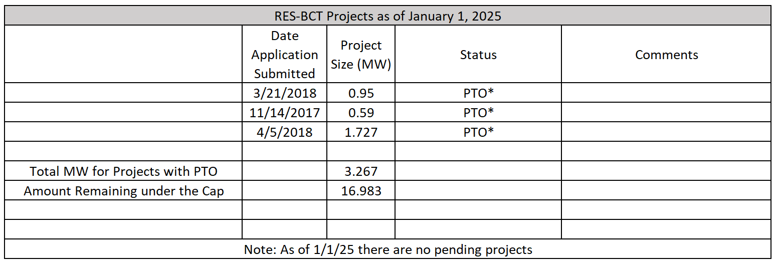
*The RES-BCT project has received Permission to Operate
Archived RES-BCT tracking files may be found here: https://www.sdge.com/node/10906

